

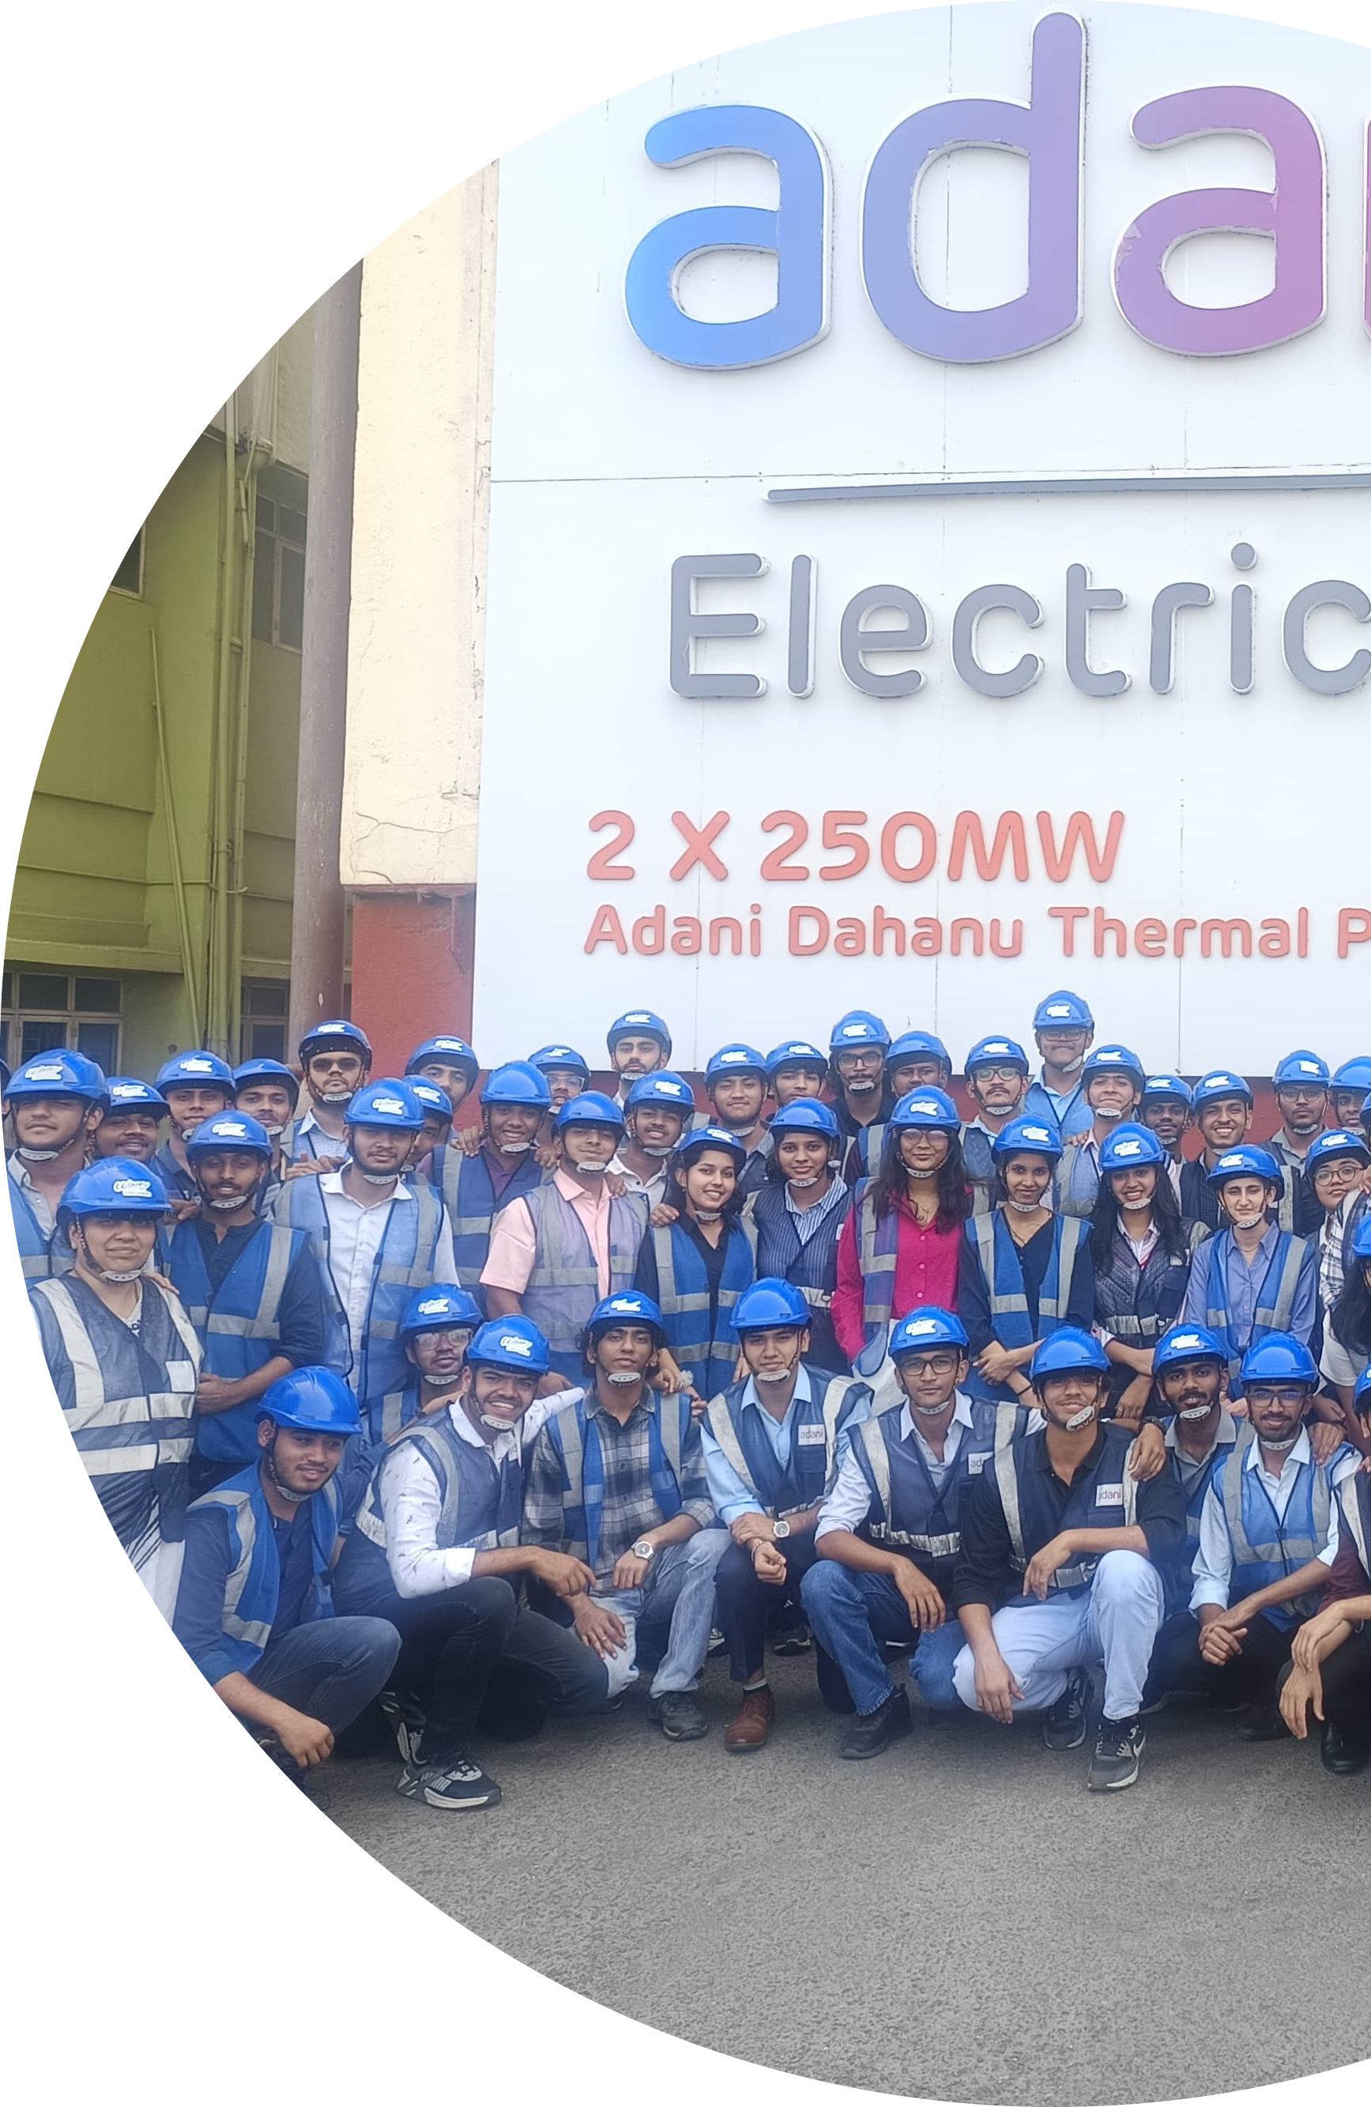

INDUSTRIAL VISIT

**REPORT**

2025

9881 X 9914

**TE Comps A**

9913



**QA IV REPORT**

BSES colony, Dahanu, Maharashtra 401608

Industrial Visit Documentation

January 15, 2025

Overview

In this report I will be talking about the industrial visit scheduled by our college, Fr. Conceicao Rodrigues College of Engineering , to the thermal power plant of the adani company at dahanu

road. The visit was aimed at informing us about the use of software related technology in the working of the power plant.

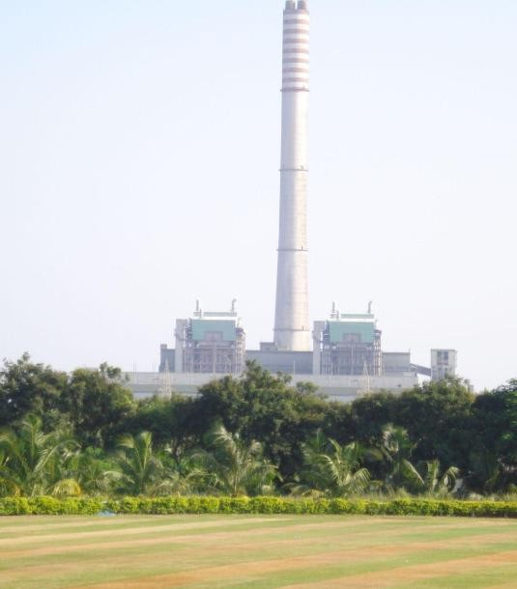

# Brief History, Capacity, and Key Operations

The Dahanu Thermal Power Station is located in Dahanu town in Maharashtra's Palghar district. It was commissioned in 1995. It comprises two units, each with a capacity of 250 megawatts (MW), totaling 500 MW. Initially constructed by BSES Limited, the plant is currently operated by Adani Electricity Mumbai Limited.

The facility utilizes coal as its primary fuel source,procured from South Eastern Coalﬁelds

Limited.

1

# Importance of the Power Plant in the Energy Sector

The Dahanu Power Plant plays a crucial role in supplying electricity to Maharashtra, particularly the Mumbai region. Its strategic location along the Mumbai-Ahmedabad rail line facilitates eﬃcient coal transportation and power distribution. By contributing 500 MW to the grid, the plant helps meet the region's energy demands, supporting residential, commercial, and industrial activities.

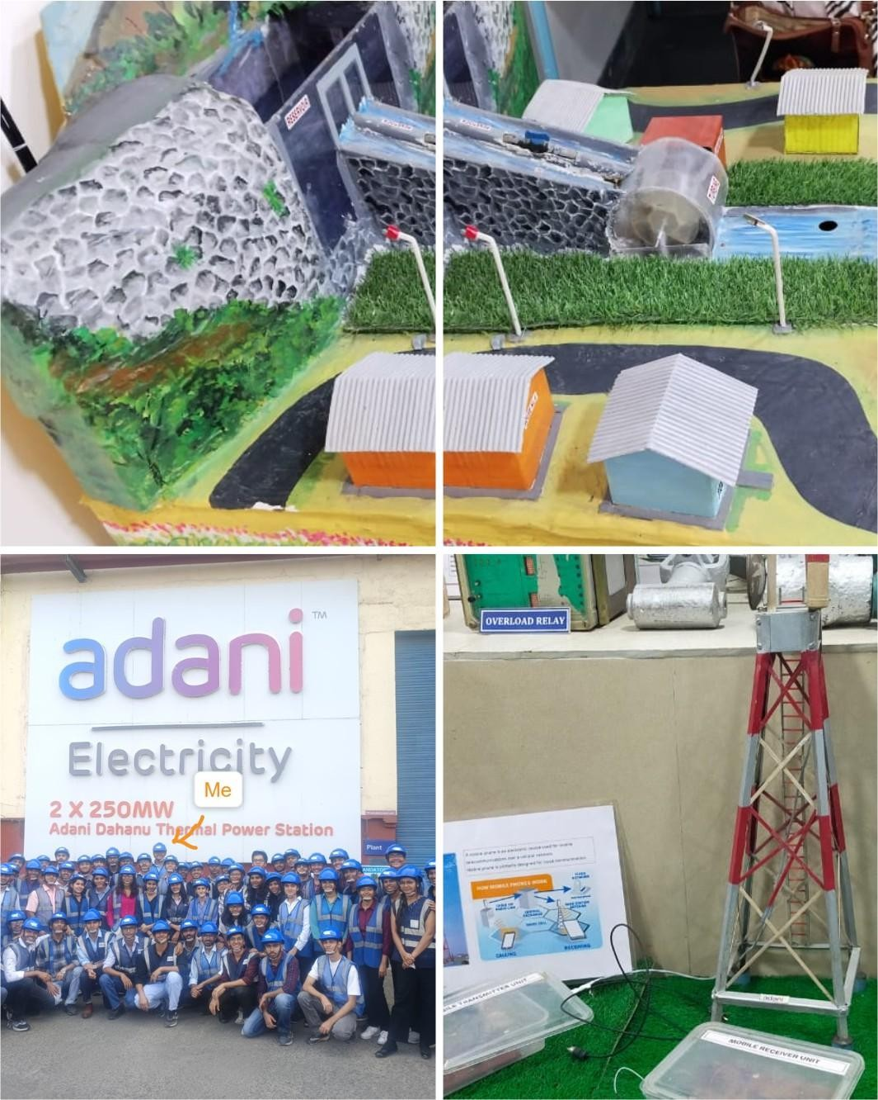

Application of Quality Analysis (QA) to Data Collected in Adani Dahanu Power Plant

Quality Analysis (QA) plays a vital role in improving the efficiency, reliability, and sustainability of the Adani Dahanu Power Plant by analyzing the data collected through IoT sensors. The plant generates large volumes of real-time data from various sources such as temperature, pressure, emissions, and energy consumption. Applying QA to this data ensures accuracy, consistency, and actionable insights to optimize plant performance and reduce downtime.

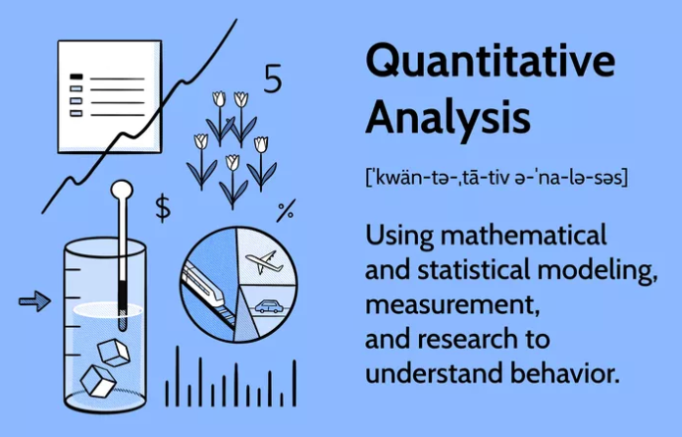

# Speciﬁc Use Cases

## Data Validation and Cleaning:

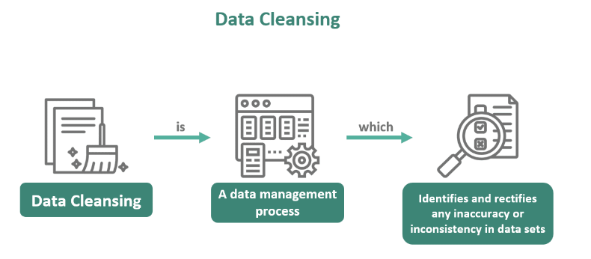

Before analysis, the data collected from IoT sensors must be validated and cleaned to ensure accuracy and consistency.

* Data Filtering: Remove noise and irrelevant data points.
* Error Detection: Identify and correct inconsistencies (e.g., negative temperature values).
* Handling Missing Data: Use statistical methods (mean/median imputation) to fill gaps in data.

*Example:*  
If a temperature sensor records a value of -100°C, QA will detect this as an invalid reading and either correct or discard it.

1. **Statistical Quality Control:** 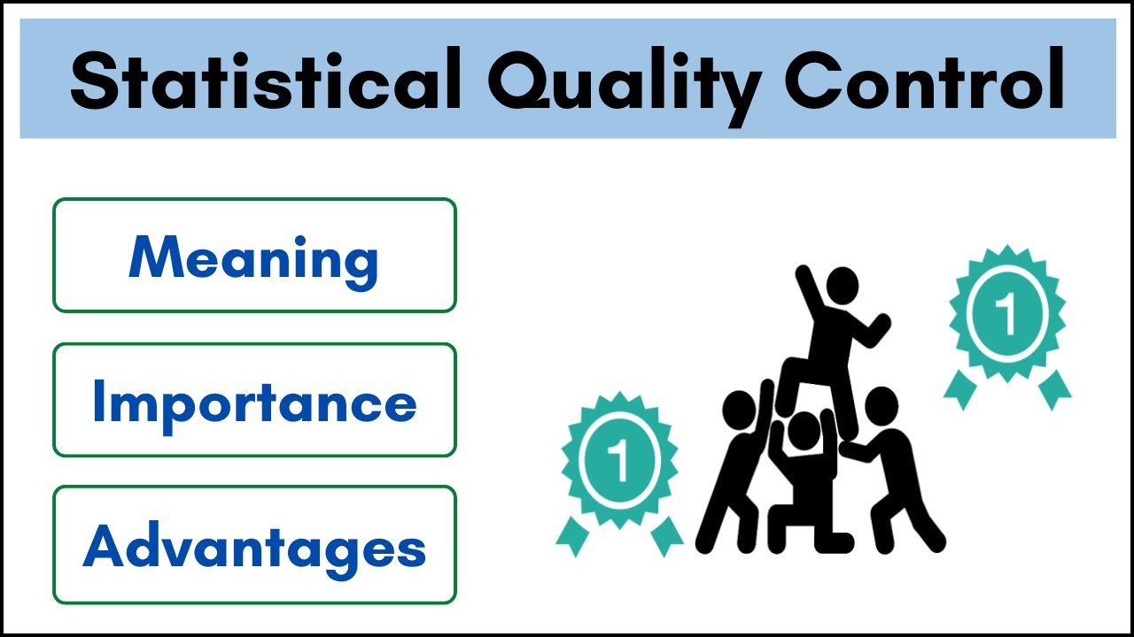

Statistical methods are used to monitor and control operational performance.

* Control Charts: Track variations in parameters like pressure and temperature to ensure they remain within safe limits.
* Process Capability Analysis: Measure how well the plant’s processes meet operational standards.
* Outlier Detection: Identify extreme values and investigate the causes.

Example:  
If a control chart shows increasing pressure variation, QA will trigger a maintenance check before a breakdown occurs.

## Energy Eﬃciency:

QA improves energy efficiency by identifying energy waste, optimizing load distribution, and reducing heat loss. Real-time monitoring and benchmarking help adjust operations, lowering costs and improving performance.

# How Does QA Enhance Operational Eﬃciency and Reduce Costs:

QA improves operational efficiency by analyzing data to identify performance gaps and optimize processes. It helps detect anomalies early, enabling predictive maintenance that reduces unplanned outages and lowers maintenance costs. By monitoring energy consumption and equipment performance, QA minimizes waste, enhances reliability, and extends the lifespan of critical components

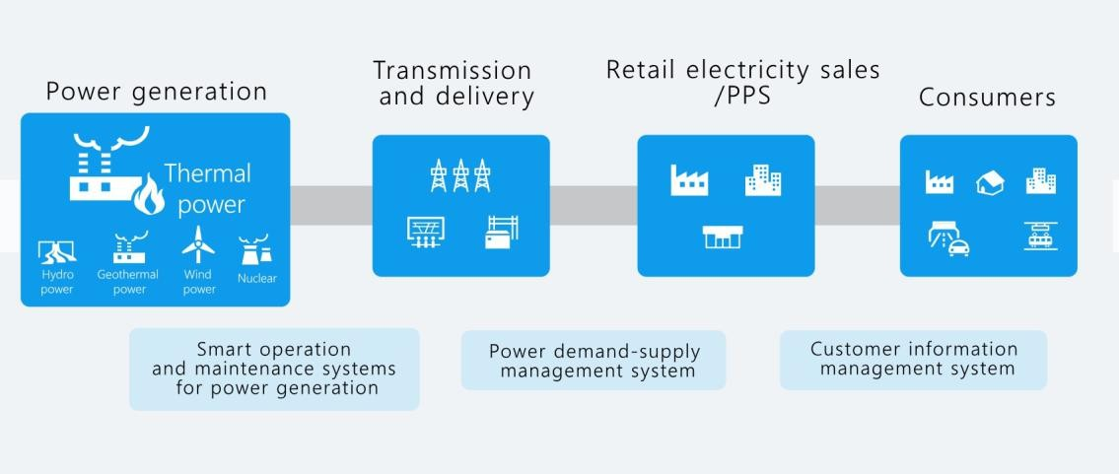

# Impact on Sustainability and Environmental Compliance

QA enhances sustainability by ensuring efficient use of resources and monitoring emissions to meet environmental standards. Accurate data analysis helps reduce waste, optimize energy consumption, and minimize the plant’s environmental footprint.

**Challenges**: Since the Dahanu plant relies on older infrastructure, implementing QA systems requires upgrading equipment to enable accurate data collection and analysis. Challenges include integrating new technology with existing systems, ensuring data security, and managing large volumes of data.

**Suggestions**: Upgrading infrastructure is essential for effective QA implementation. Once upgraded, QA processes like predictive maintenance and automated monitoring can be introduced in phases to improve efficiency and compliance.

# Conclusion:

Adani Dahanu Power Plant demonstrates how Quality Analysis (QA) can enhance traditional power generation by improving efficiency, reducing costs, and ensuring environmental compliance through accurate data analysis, predictive maintenance, and optimized resource management.